**VISVESVARAYA TECHNOLOGICAL UNIVERSITY**

**“JnanaSangama”, Belgaum -590014, Karnataka.**



# LAB REPORT on

**Machine Learning**

**(20CS6PCMAL)**

***Submitted by***

# ISHIKA SINGHAL (1BM19CS064)

## *in partial fulfillment for the award of the degree of*

**BACHELOR OF ENGINEERING**

***in***

# COMPUTER SCIENCE AND ENGINEERING



# B.M.S. COLLEGE OF ENGINEERING BENGALURU-560019 May-2022 to July-2022

**(Autonomous Institution under VTU)**

**B. M. S. College of Engineering,**

**Bull Temple Road, Bangalore 560019**

(Affiliated To Visvesvaraya Technological University, Belgaum)

## Department of Computer Science and Engineering



### CERTIFICATE

This is to certify that the Lab work entitled “**MACHINE LEARNING**” carried out by **ISHIKA SINGHAL (1BM19CS072),** who is bonafide student of **B. M. S. College of Engineering.** It is in partial fulfillment for the award of **Bachelor of Engineering in Computer Science and Engineering** of the Visvesvaraya Technological University, Belgaum during the year 2022. The Lab report has been approved as it satisfies the academic requirements in respect of a **Machine Learning - (20CS6PCMAL)** work prescribed for the said degree.

Name of the Lab-Incharge **Dr. Asha G R**

Designation Assistant Professor

Department of CSE Department of CSE

BMSCE, Bengaluru BMSCE, Bengaluru

`

# Index Sheet

|  |  |  |
| --- | --- | --- |
| **Sl.**  **No.** | **Experiment Title** | **Page No.** |
| **1** | **Find S Algorithm** | **4** |
| **2** | **Candidate Elimination Algorithm** | **5** |
| **3** | **ID3 Algorithm** | **6** |
| **4** | **Naïve Bayes** | **9** |
| **5** | **Linear Regression** | **11** |
|  |  |  |
|  |  |  |
|  |  |  |
|  |  |  |
|  |  |  |
|  |  |  |
|  |  |  |
|  |  |  |
|  |  |  |
|  |  |  |

## Course Outcome

|  |  |
| --- | --- |
| **CO1**  **CO2**  **CO3**  **CO4** | Ability to **apply** the different learning algorithms.    Ability to **analyse** the learning techniques for given dataset.    Ability to **design** a model using machine learning to solve a problem.    Ability to **conduct** practical experiments to solve problems using appropriate machine learning techniques. |

## 1. Find S Algorithm

Implement and demonstrate the FIND-S algorithm for finding the most specific hypothesis based on a given set of training data samples

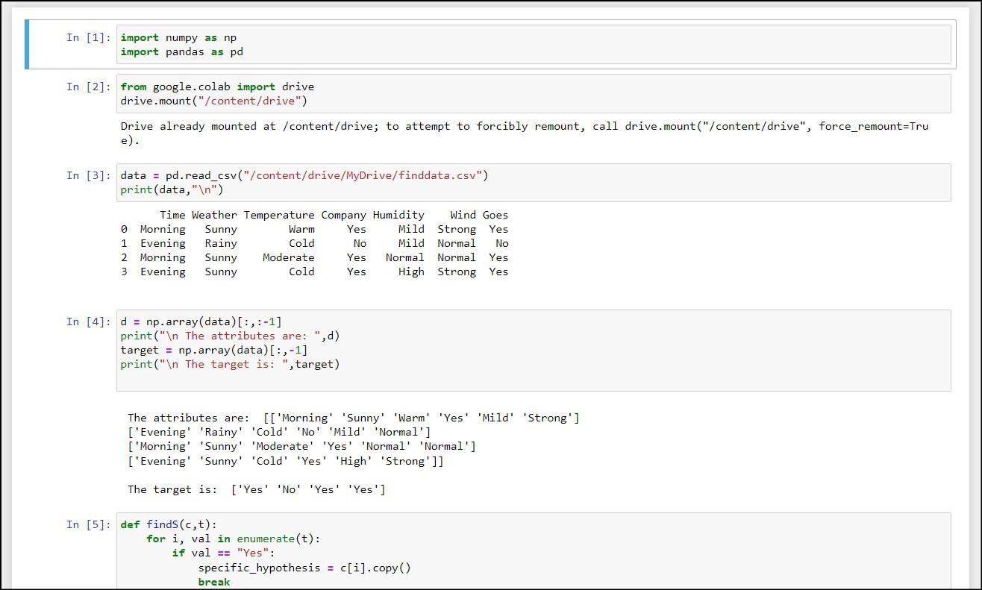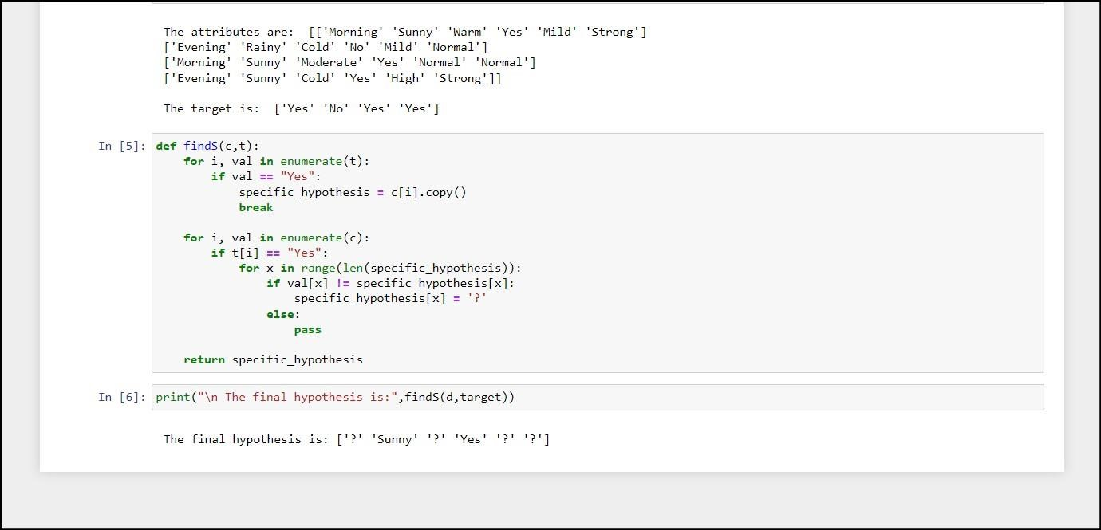

## 2. Candidate Elimination Algorithm

For a given set of training data examples stored in a .CSV file, implement and demonstrate the Candidate-Elimination algorithm to output a description of the set of all hypotheses consistent with the training examples.

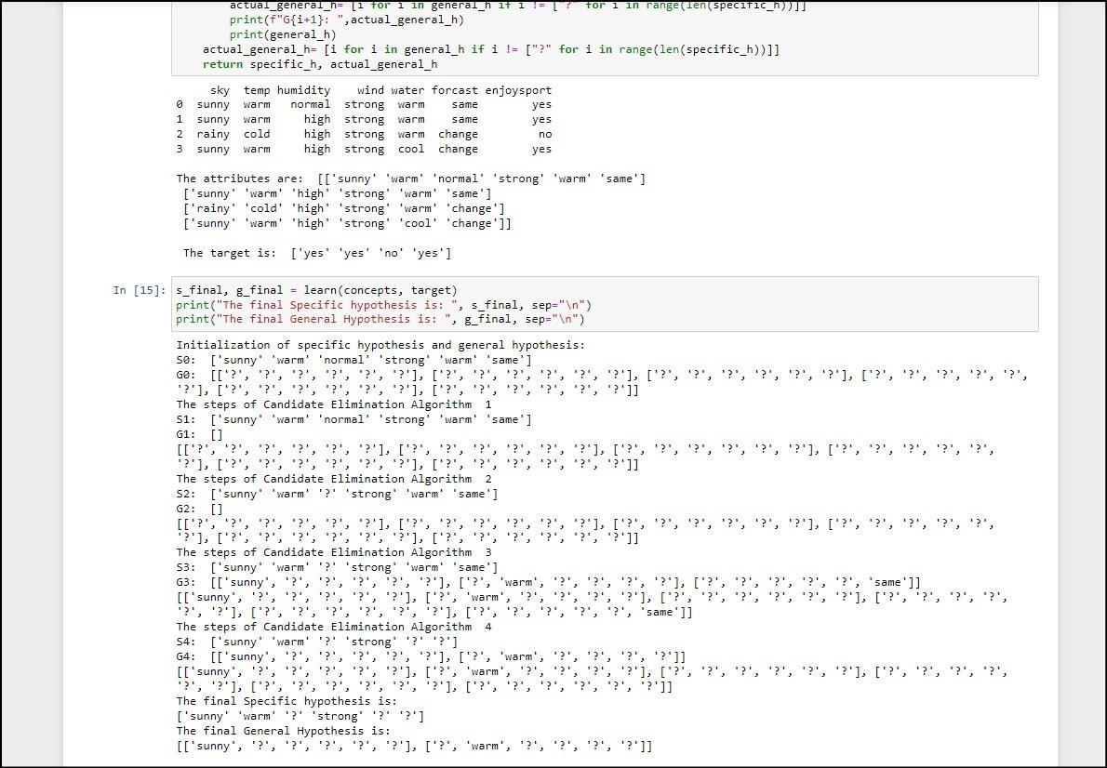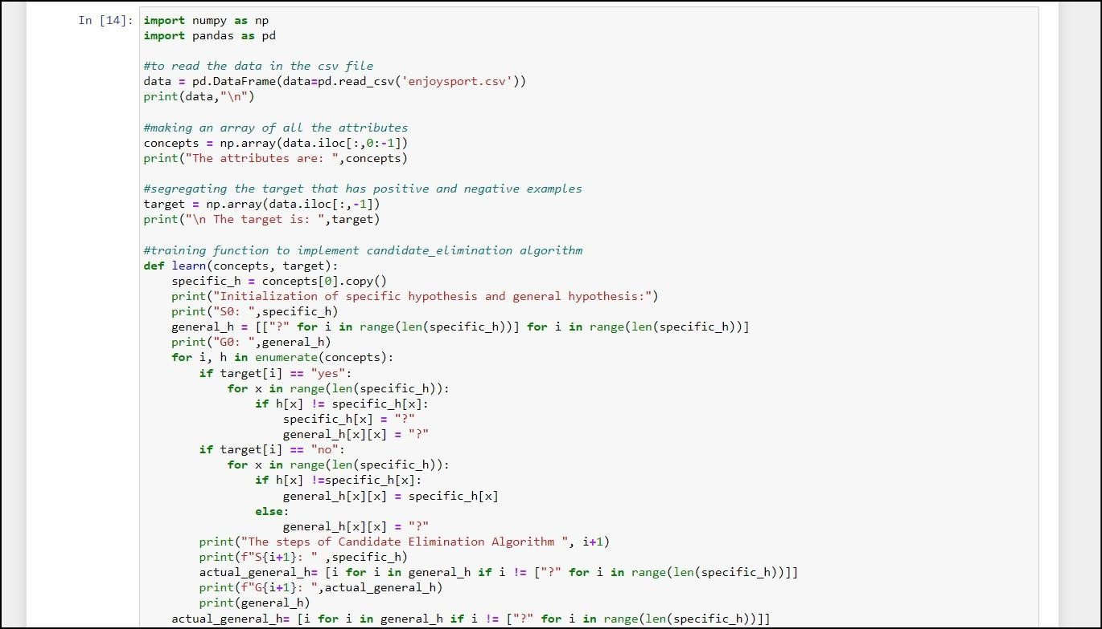

## 3. ID3 Algorithm

Write a program to demonstrate the working of the decision tree based ID3algorithm. Use an appropriate data set for building the decision tree and apply this knowledge to classify a new sample.

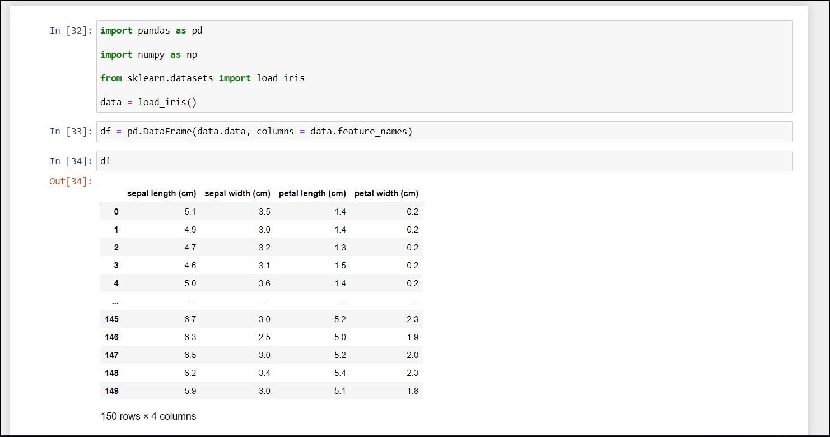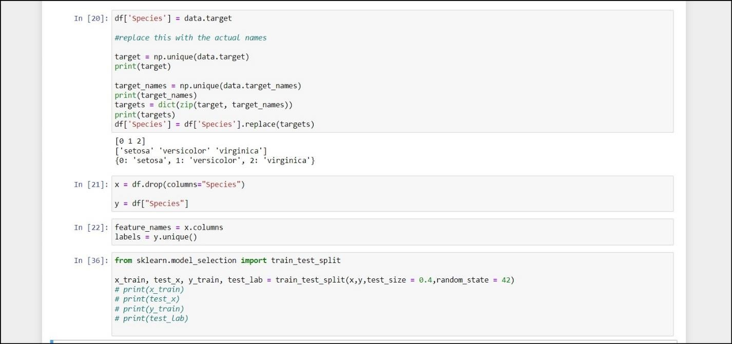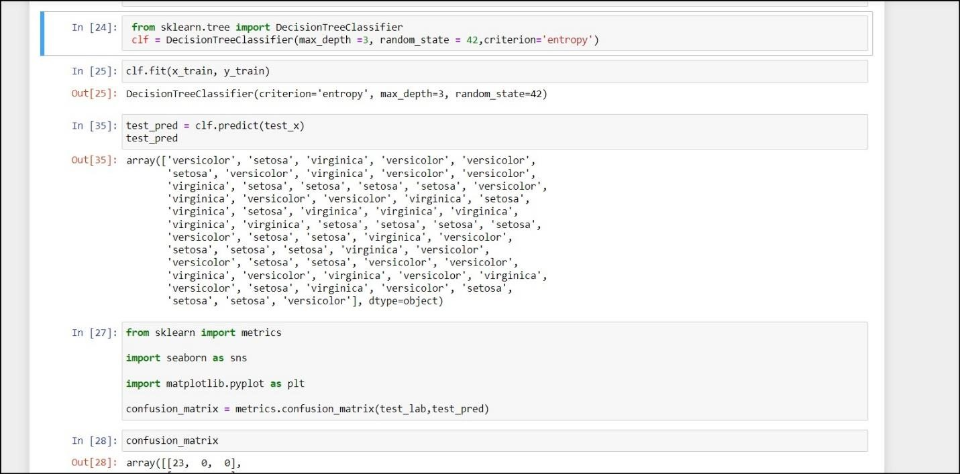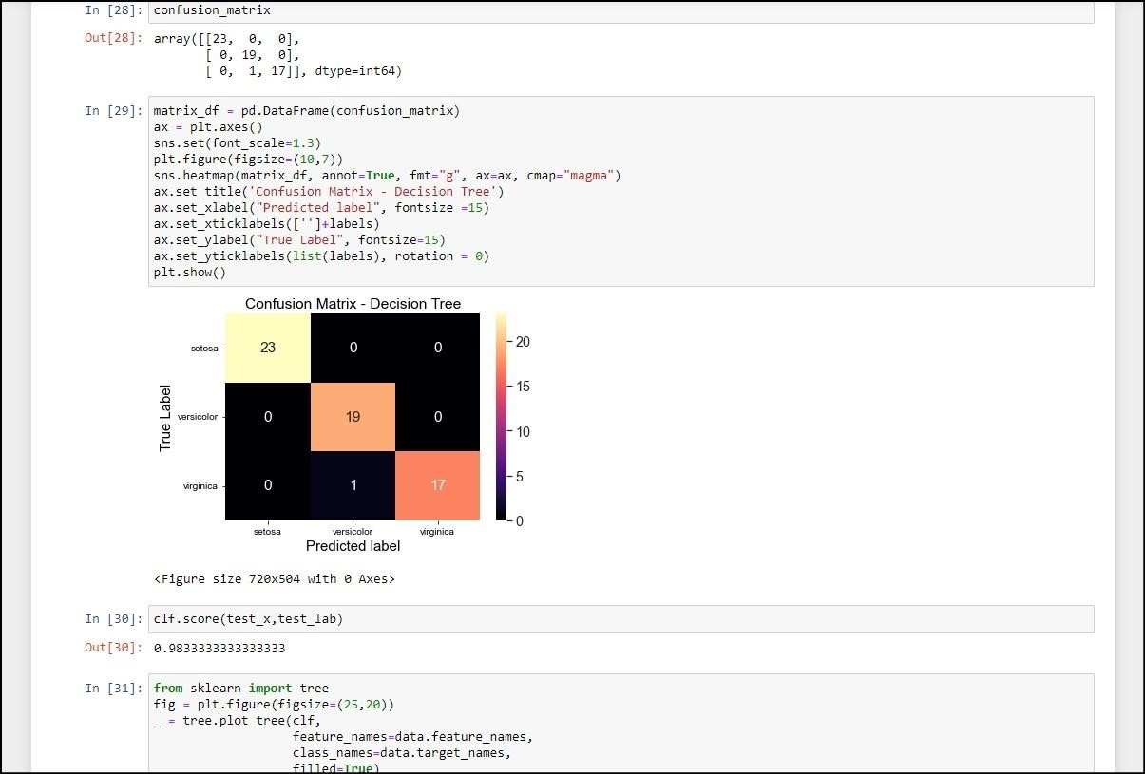

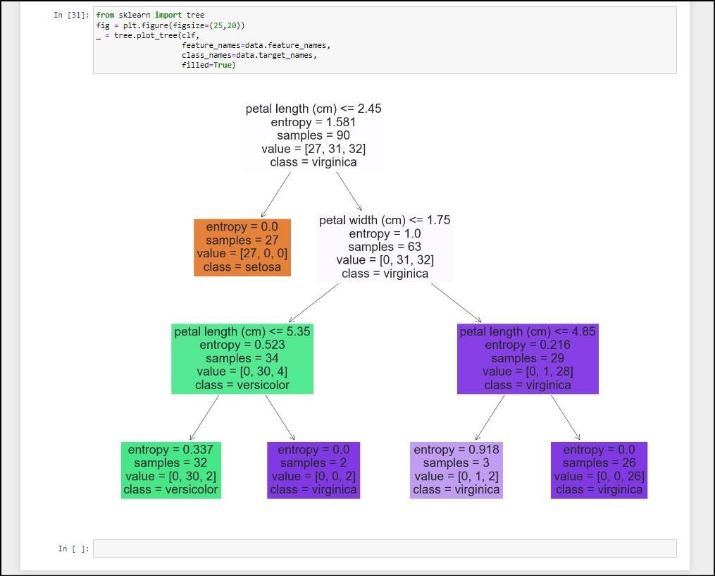

## 4. Naïve Bayes

Write a program to implement the naïve Bayesian classifier for a sample training data set stored as a .CSV file. Compute the accuracy of the classifier, considering few test data sets

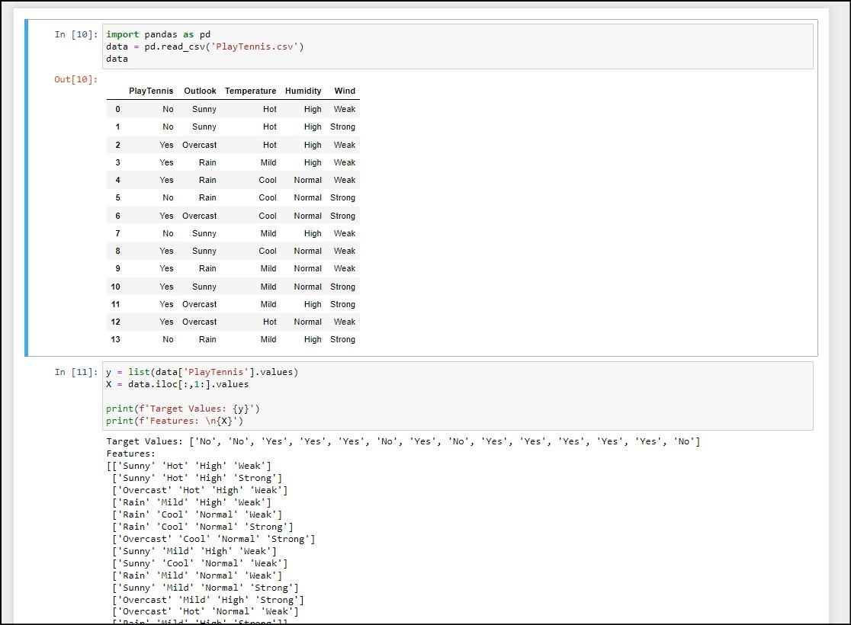

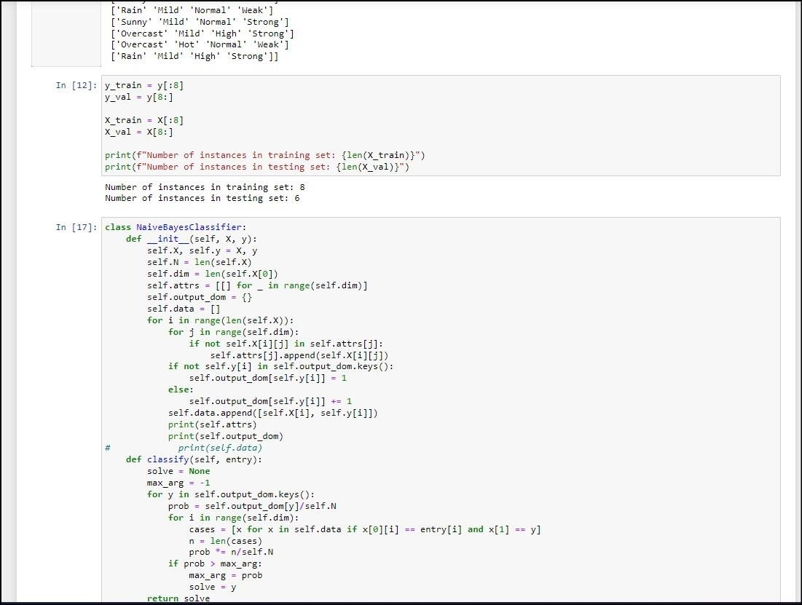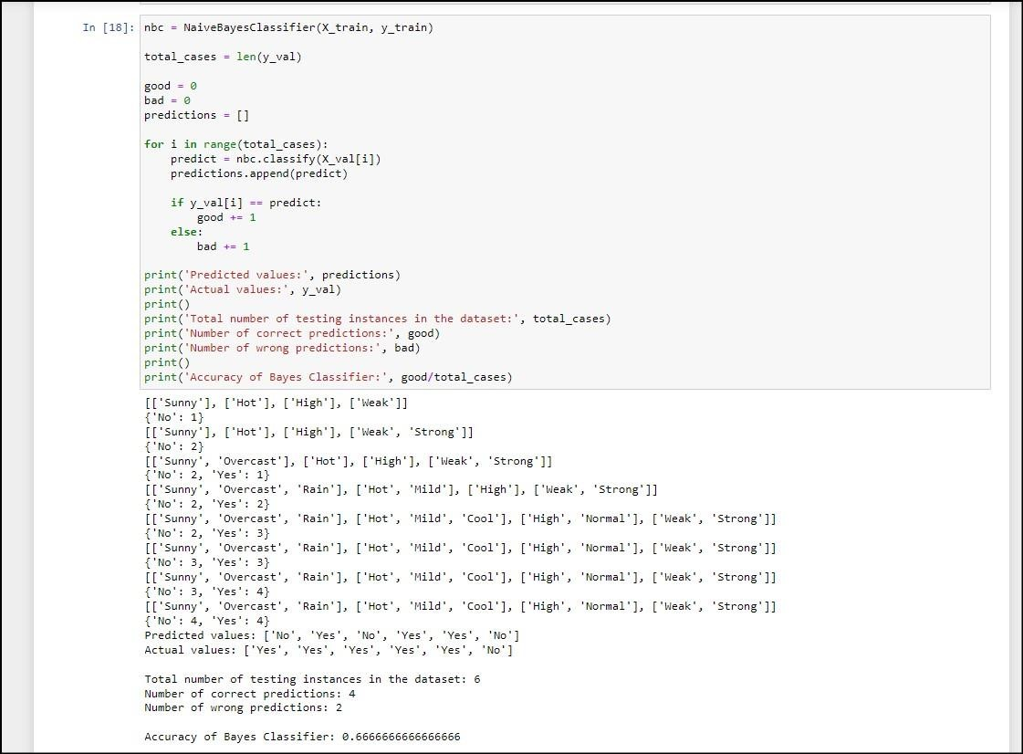

## 5. Linear Regression

Implement the Linear Regression algorithm in order to fit data points. Select appropriate data set for your experiment and draw graphs.

